VISUALIZATION TOOL FOR ELECTRIC VEHICLE CHARGE AND RANGE ANALYSIS

*PROJECT FLOW*

## Data collection and extraction from database

Collect the dataset

Connect dataset with tableau

## Data visualizations

No.of unique visualization

## Dashboard

Dashboard 1

Dashboard 2

## Story

Web integration

# DATA COLLECTION AND EXTRACTION FROM DATABASE

## Collect the dataset

Please use the link to download the dataset: [https://www.kaggle.com/datasets/geoffnel/evs-one-electric-vehicle-](https://www.kaggle.com/datasets/geoffnel/evs-one-electric-vehicle-dataset)

[dataset%20](https://www.kaggle.com/datasets/geoffnel/evs-one-electric-vehicle-dataset)

## Connect the dataset to tableau

Check the below link to connect the dataset to tableau

Explanation video link:

<https://drive.google.com/file/d/13IccmY9UFGio9ad_VFX0B19l8O-TK_dt/view?usp=drivesdk>

# DATA VISUALIZATIONS

## No.of unique visualizations

### Top 10 brand accel sec and top speed

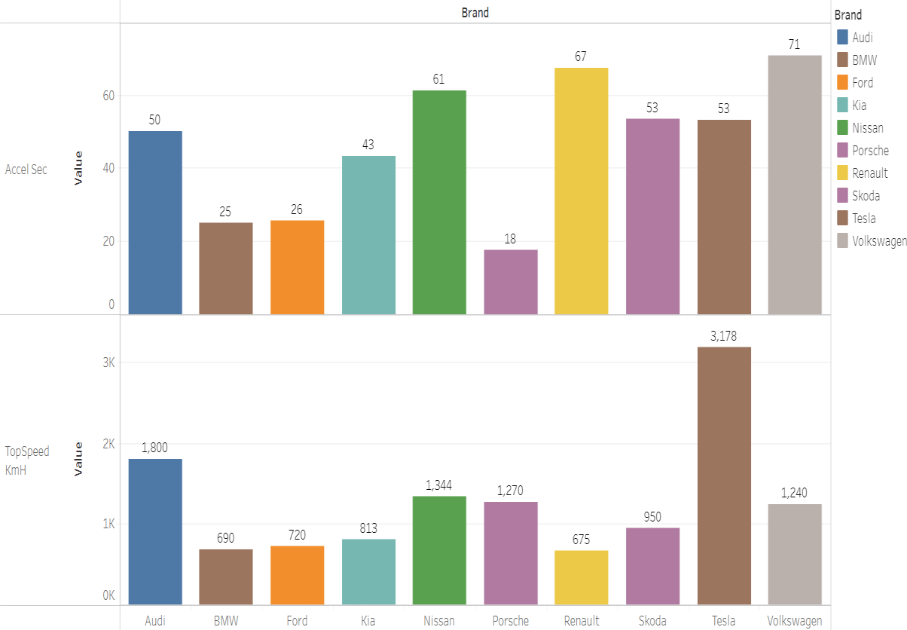

Explanation video link:

<https://drive.google.com/file/d/13Ynpf4AkfhlW-Jo4jsmh7dIdI4vXPC9L/view?usp=drivesdk>

The above visualization decribes about the Brand and sum of TopSpeed KmH. Color shows sum of TopSpeed KmH. Size shows sum of Accel Sec.

The marks are labled by Brand and sum of TopSpeed KmH. The view is filtered on Brand,which keeps 10 of 33 members.

Here the Top AccelSec of the Brand is **Volkswagen** and the TopSpeed of the Brand is **Tesla.**

### Top 10 Brand Price

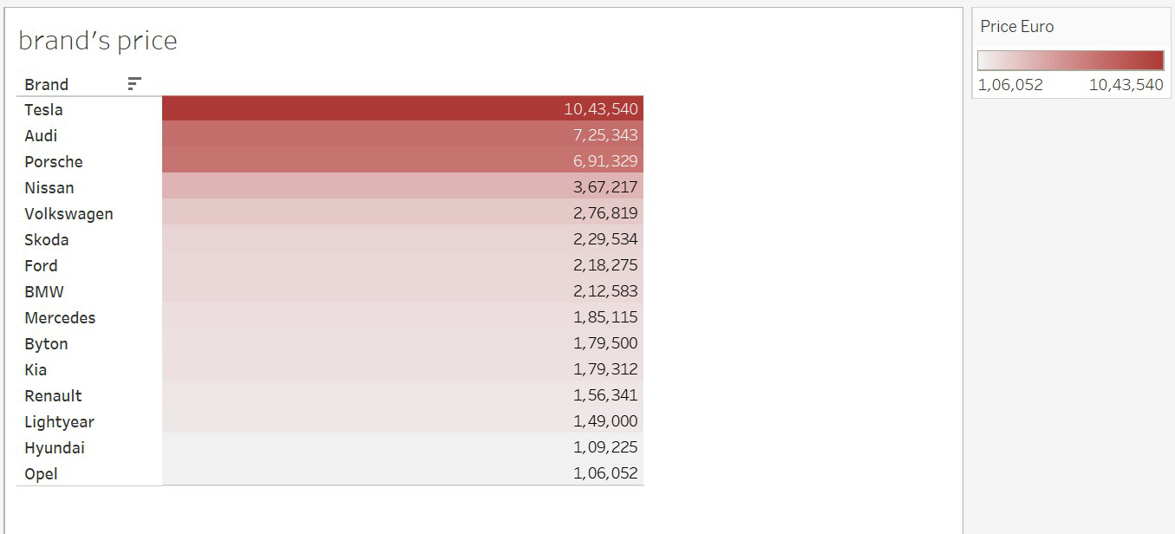

Explanation video link:

<https://drive.google.com/file/d/13cYQZ9mw3xK-Svu8wNizYNRhe4fuEEPg/view>

The above visualization describes about sum of Price Euro broken by Brand. Color shows sum of Price Euro. The marks are labeled by sum of Price Euro. The view is filtered on Brand, which keeps 10 of 33 members.

Here the highest Price of the Brand is **Tesla.**

### Top 10 Brand Body Style

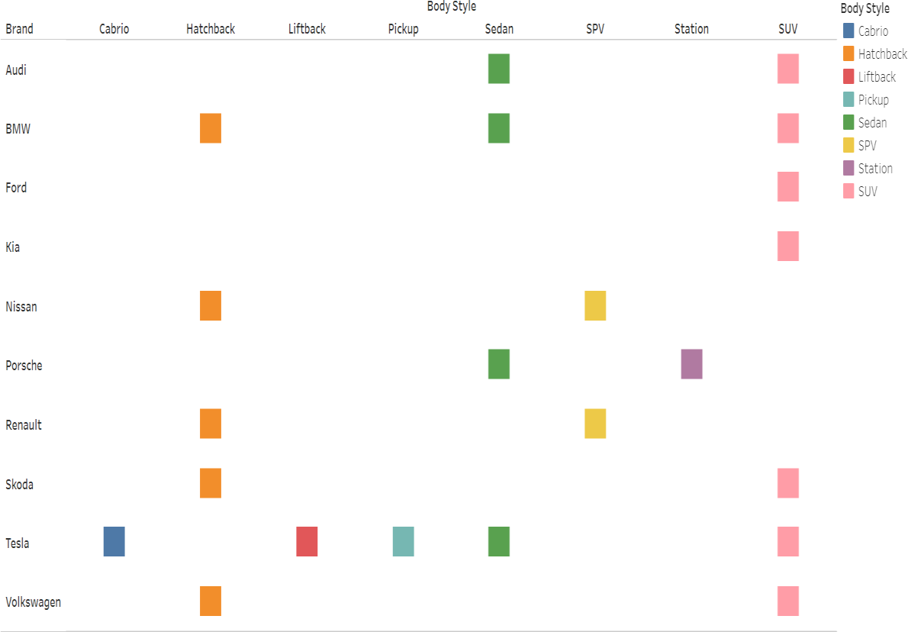

Explanation video link: <https://drive.google.com/file/d/13jICRuaVPX7GZ7DoxEoR6ZdIu-95ONtZ/view>

The above visualization describes about the Body Style of the Brand. Color shows details about Body Style . The view is filtered on Brand. The Brand filter keeps 10 of 33 members the marks are labeled by Body Style.

Here the **Tesla** has more number of Body Style

### Top 10 Brand Fast Charging

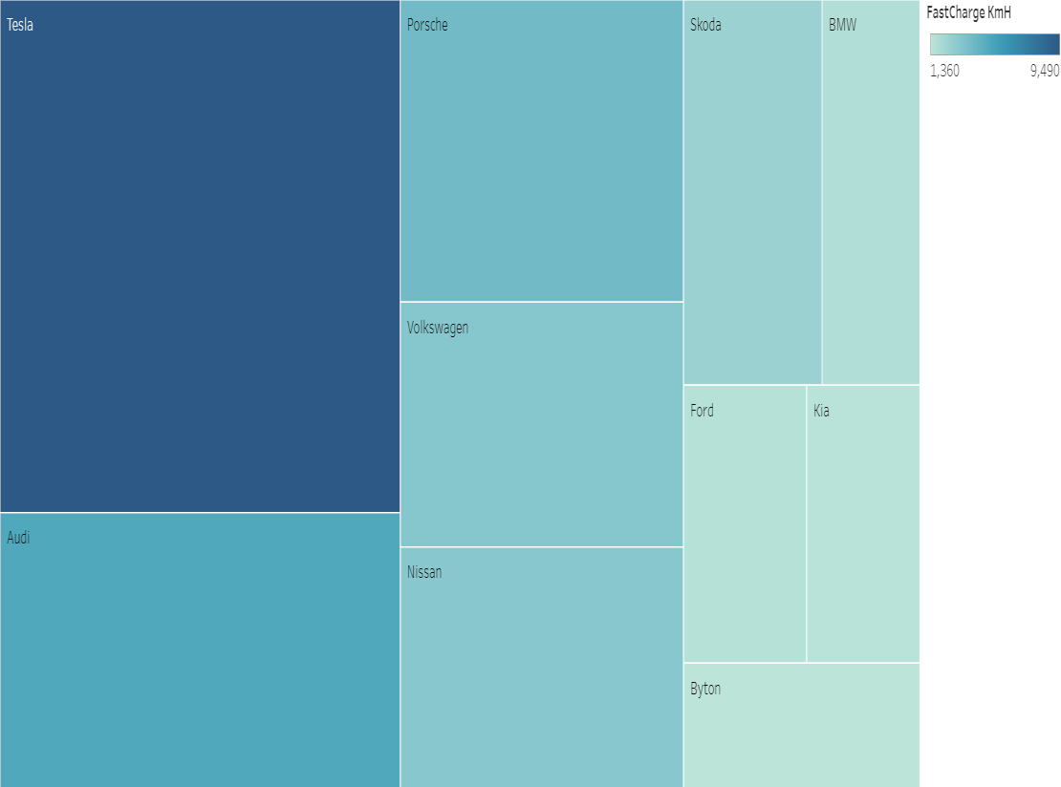

Explanation video link: <https://drive.google.com/file/d/13a04F4ZawAxxryIONUhxgIdJtMiDsstv/view>

The above visualization describes about the Brand’s Fast Charging. Color shows sum of Fast Charge KmH. The marks are labeled by Brand. The view is filtered on Brand, which keeps 10 of 33 members

Here the **Tesla** has highest Fast Charge KmH.

### Top 10 Brand Data Count

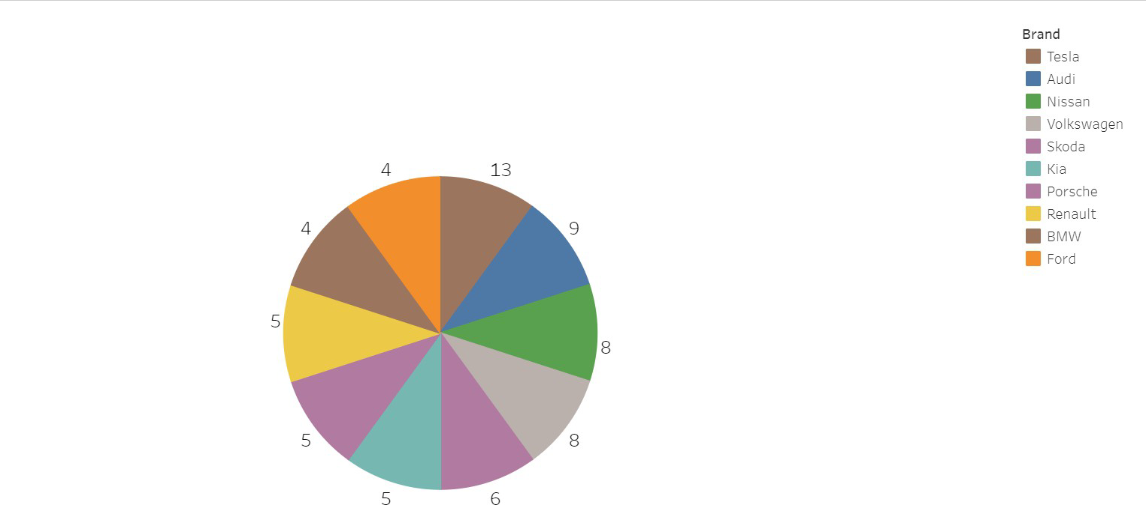

Explanation video link:

<https://drive.google.com/file/d/13jOdVATop-Tg6n8dJv0A_x5n2ehZGd-s/view>

The above visualization describes about Count of ElectricalData_Clean. Color shows details about Brand. The marks are labeled by count of the ElectricalData_Clean. The view is filtered on Brand ,which keeps 10 of 33 members.

Here the maximum count of ElectricCarData is **Audi**.

### Top 10 Brand Sum Of Seats

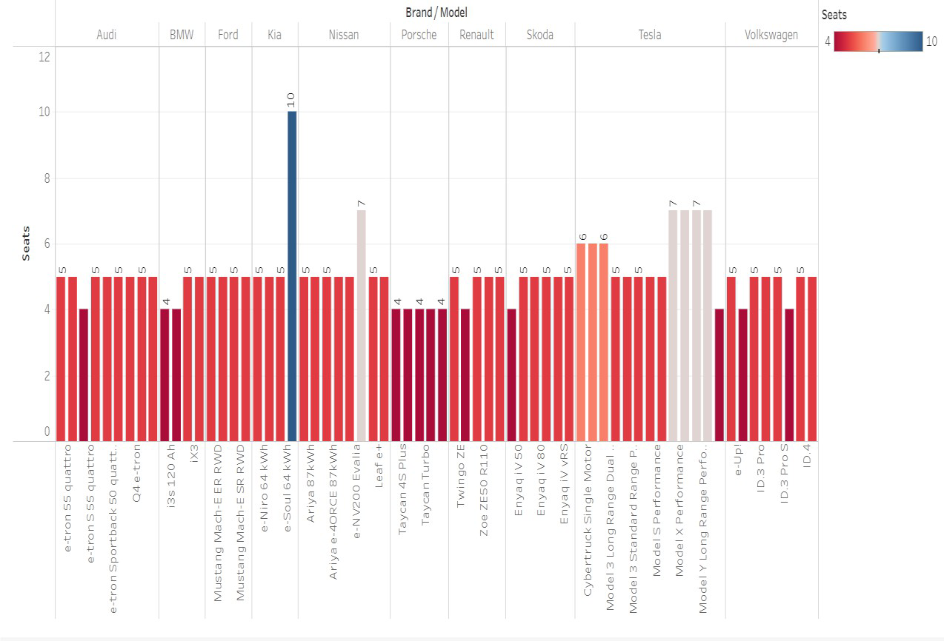

Explanation video link: <https://drive.google.com/file/d/13d3JgBnHJ4PJgMRePJiPqjOmO9rbttjH/view>

The above visualization describes about the sum of seats for each model broken down by Brand. Color shows sum of seats.The view is filtered on Brand, which keeps 10 of 33 members.

Here **kia** contain maximum number of seats

## Top 10 Brand Range And Efficiency

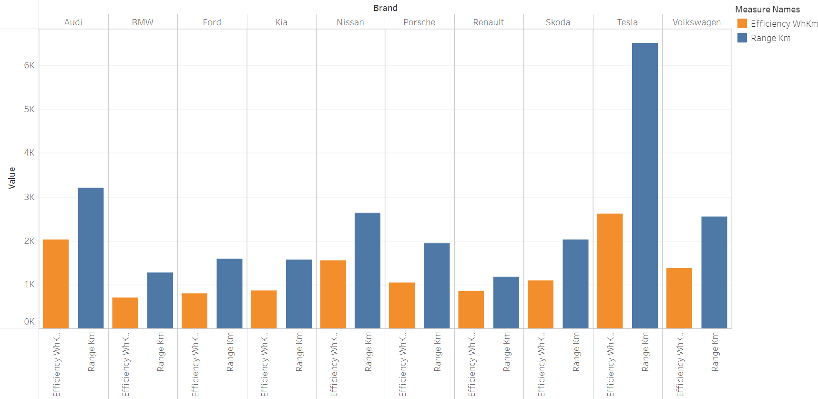

Explanation video link:

[https://drive.google.com/file/d/13tKx8g4GiwIwrpgLNwiSLIgzYP0U2Uje/view?u](https://drive.google.com/file/d/13tKx8g4GiwIwrpgLNwiSLIgzYP0U2Uje/view?usp=drivesdk) [sp=drivesdk](https://drive.google.com/file/d/13tKx8g4GiwIwrpgLNwiSLIgzYP0U2Uje/view?usp=drivesdk)

The above visualization describes about the Efficiency WhKm and Range Km for each Brand. Color shows detail about Efficiency WhKm and Range Km. the view is filtered on Brand, which keeps 10 of 33 members

Here **Tesla** have both maximum Efficiency WhKm and Range Km.

# DASHBOARD

### Dashboard 1:

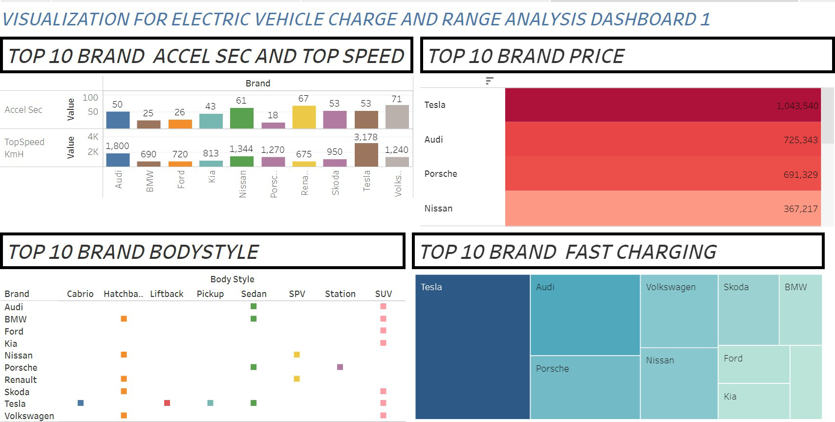

The above Dashboard1 contains four visualizations for electric vehicle charge and range

Explanation video link:

<https://drive.google.com/file/d/13SsN6pte15g3IadC8yhCbAO__EAL0fjA/view?usp=drivesdk>

### Dashboard 2:

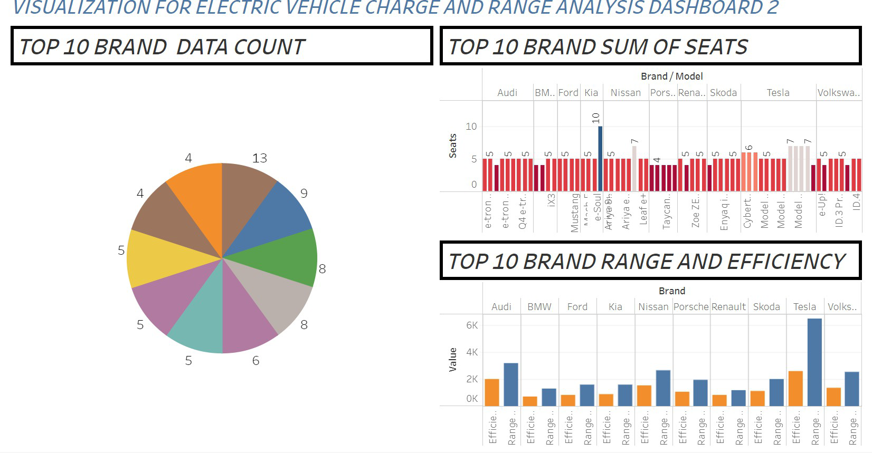

The above Dashboard2 contains three visualizations for electric vehicle charge and range

Explanation video link: [https://drive.google.com/file/d/13UUvTd2cEtz1YXEf9386e9z7hG_KowVJ/view](https://drive.google.com/file/d/13UUvTd2cEtz1YXEf9386e9z7hG_KowVJ/view?usp=drivesdk)

[?usp=drivesdk](https://drive.google.com/file/d/13UUvTd2cEtz1YXEf9386e9z7hG_KowVJ/view?usp=drivesdk)

1. STORY
   1. Web Integration

[*https://public.tableau.com/app/profile/darshika.y/viz/DATAANALYTICSP*](https://public.tableau.com/app/profile/darshika.y/viz/DATAANALYTICSPROJECT_16893337561590/Story1)[*ROJECT_16893337561590/Story1*](https://public.tableau.com/app/profile/darshika.y/viz/DATAANALYTICSPROJECT_16893337561590/Story1)

*Explanation Video:*

[*https://drive.google.com/file/d/12ZcP2-bth8U9lWaE8QlzgPA6aTE4mSVq/view?usp=drivesdk*](https://drive.google.com/file/d/12ZcP2-bth8U9lWaE8QlzgPA6aTE4mSVq/view?usp=drivesdk)